Coffee Shop

Contributors:

BitCafe

Ivo Dimov

[IMDimov18@codingburgas.bg](mailto:IMDimov18@codingburgas.bg)

Kristian Neikov

[KVNeikov18@codingburgas.bg](mailto:KVNeikov18@codingburgas.bg)

Mentor:

Mariana Encheva

1.Goals of the project

We decided that we want to make a menu for coffee shop. We made our program as easy as possible for interaction. Our program will save plenty of time than doing everything by hand. The program we created can be used not only in coffee shops, but in restaurants, shops and so on. The program will make it easier to collect orders.

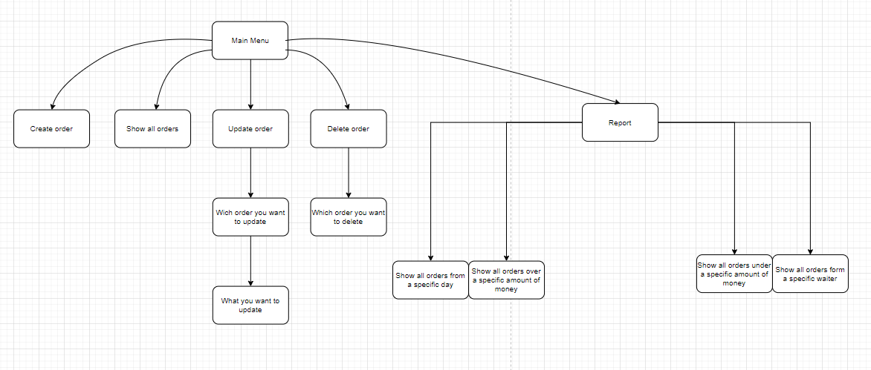

|  |  |  |  |
| --- | --- | --- | --- |
| Create order | Creates orders by asking about what the table’s number, waiter name, client’s order, the duration, the amount of money and what day it is. | Int number-claims the number of the table  String waiterName-claims the name of the waiter  String clientOrder-claims the order of the client  String time-claims that how much time did the client stay  Int bill- claims the amount of money that the client paid  String dof-claims what day it is entered | It does not return a value. |
| Show all orders | Show all entered orders | It doesn’t have variables | Shows all options entered by the create order function |
| Update order | Asking witch order to be rewritten, then asking witch variable to be updated | Int choice- claims and shows to the switch case witch case has been chosen | It does not return a value. |
| Delete order | Asking witch order to be deleted and it deletes it | Int choice- claims and shows to the switch case witch case has been chosen | It does not return a value. |
| Report | Shows orders under specific circumstances | Int choice-claims and shows to the switch witch case has been chosen:  -specific day;  -amount of money;  -from specific waiter; | Returns all orders that are eligble |